MINI PROJECT INITIAL REPORT
Speech Enhancement System using Digital Signal Processing

Title
Speech Enhancement System using Digital Signal Processing

Brief Abstract
This project focuses on the design and implementation of a Speech Enhancement System using Digital Signal Processing (DSP) techniques to improve the quality and intelligibility of speech signals corrupted by background noise. In real-world communication environments, speech signals are often affected by various types of noise such as environmental sounds, electrical interference, and channel distortions. The proposed system processes noisy speech signals using frequency-domain analysis and noise reduction algorithms to suppress unwanted noise while preserving important speech components. The project is implemented in MATLAB and demonstrates the effectiveness of speech enhancement techniques through waveform analysis, spectral comparison, and performance evaluation.

Keywords
Speech Enhancement, Digital Signal Processing, Noise Reduction, Spectral Analysis, Adaptive Filtering, Audio Signal Processing, MATLAB

Objectives
- To study the effects of noise on speech signals in real-world communication systems.
- To design and implement a speech enhancement algorithm using digital signal processing techniques.
- To analyze speech signals in both time and frequency domains.
- To reduce background noise while maintaining speech intelligibility.
- To evaluate the performance of the proposed system using graphical and numerical analysis.

Prior Art
Traditional speech communication systems often rely on basic analog filtering techniques to reduce noise. Such methods are effective only for narrowband noise and fail to perform well in the presence of non-stationary or broadband noise. Conventional fixed filters also lack adaptability and may distort speech components while removing noise.
Several digital speech processing methods have been proposed in literature, including Wiener filtering and spectral subtraction techniques. While these methods improve noise suppression, they may introduce artifacts such as musical noise if not properly designed. This project builds upon established DSP approaches and focuses on implementing a practical and educational speech enhancement system suitable for academic study and laboratory experimentation.

Problems Addressed and Limitations
Problems Addressed:
- Degradation of speech quality due to environmental and electronic noise.
- Reduced speech intelligibility in communication systems operating in noisy conditions.
- Inefficiency of simple filtering techniques in handling non-stationary noise.
Limitations:
- Performance depends on accurate noise estimation.
- Sudden changes in noise characteristics may affect enhancement quality.
- The system focuses on noise reduction and does not perform speech recognition or classification.
- Musical noise artifacts may appear at very low signal-to-noise ratios.

Detailed Description of the Project
The Speech Enhancement System begins with the acquisition of a clean speech signal, either through recording or by loading an audio file. To simulate real-world scenarios, additive noise such as white Gaussian noise or recorded environmental noise is introduced into the speech signal. The noisy speech signal is then segmented into short frames, as speech is considered quasi-stationary over small time intervals.
Each frame is windowed and transformed into the frequency domain using the Fast Fourier Transform (FFT). Noise characteristics are estimated by analyzing low-energy segments or using statistical averaging methods. The estimated noise spectrum is subtracted from the noisy speech spectrum using a spectral subtraction technique. This process reduces noise-dominated frequency components while preserving speech-related frequencies.
After noise suppression, the modified frequency-domain signal is converted back to the time domain using the Inverse Fast Fourier Transform (IFFT). The enhanced speech frames are then reconstructed to form the final output signal. Performance evaluation is carried out by comparing clean, noisy, and enhanced speech signals using time-domain plots, spectrograms, and signal-to-noise ratio measurements. The entire system is implemented and tested in MATLAB.

Expected outcomes
The project is expected to produce a noticeable improvement in speech quality by effectively reducing background noise while preserving speech intelligibility. Visual analysis using waveforms and spectrograms will demonstrate reduced noise components in the enhanced speech signal. The project provides practical insight into digital speech processing techniques and serves as a foundation for advanced applications such as speech recognition systems, hearing aids, and mobile communication technologies.

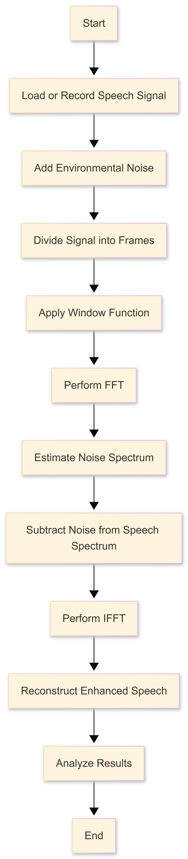
Flowchart

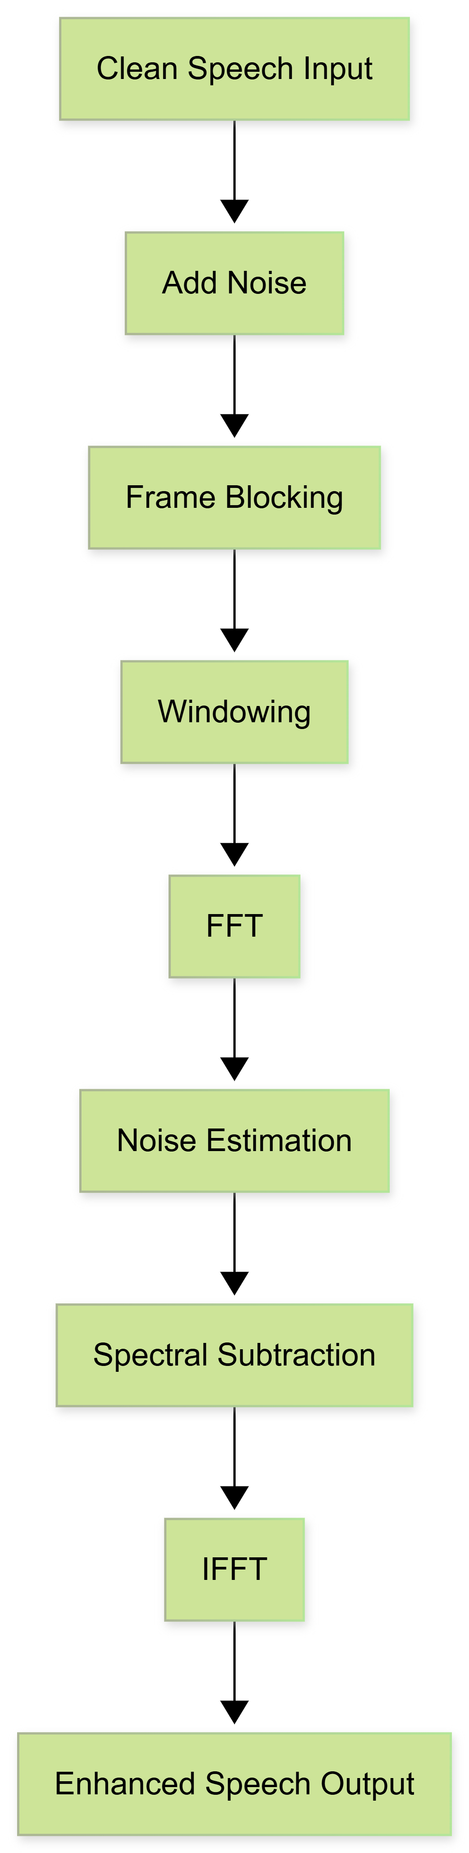
Block Diagram

References
[1] S. Boll, "Suppression of acoustic noise in speech using spectral subtraction," IEEE Transactions on Acoustics, Speech, and Signal Processing, vol. 27, no. 2, pp. 113–120, 1979.
[2] J. S. Lim, "Speech Enhancement," Prentice Hall, 1983.
[3] A. V. Oppenheim and R. W. Schafer, "Discrete-Time Signal Processing," 3rd ed., Pearson Education, 2010.
[4] MathWorks, "Speech Processing and Audio System Toolbox Documentation," 2024. Available: https://www.mathworks.com. [Accessed: Jan. 20, 2026].

